软件工程的定义

Software engineering is an engineering method that applies systematic, standardized and measurable methods to the development, operation and maintenance of software.

软件的定义

software = program + documents + data

文档的作用

Recording, Standard Description of Software Development Process, Solving Invisibility

Communication and Exchange

Management and maintenance

User service

软件的特点

More dependent on people

Development cost and schedule are difficult to estimate

Correctness is difficult to guarantee

Maintenance difficulties

No wear, no aging

软件危机（Software Crisis）

A series of serious problems encountered in the development and maintenance of computer software.

软件危机的含义

How to develop software to meet demand

How to Maintain Existing Software

软件危机的表现

Difficult to control development progress

Software workload estimation is difficult

Software quality is often unreliable

Software modification and maintenance difficulties

软件特点

Lack of visibility

Not bad, but design flaws

Large and complex

软件开发与维护问题

Demand problem

management problem

Method and Tool Problems

软件工程三要素

Based on organized quality assurance

Software engineering process is a series of organized activities, which can reasonably and timely develop computer software.

Software Engineering Method Provides "How to Do" Technology for Software Development

Software tools provide automatic or semi-automatic support for processes and methods

软件的生存期（Software Life Cycle）

Software products begin with concepts, develop, use and maintain, and eventually retire.

原则: Tasks at all stages should be as independent as possible

优点: "Break through each", "divide and govern", reduce the difficulty

Facilitate division of labor and cooperation among different personnel

Easy to adopt scientific management technology at all stages

It is easy to adopt advanced development methods and technologies at all stages.

Easy to organize and manage the whole process of software development engineering

软件过程模型

The structural framework of the whole process, activities and tasks of software development.

作用

Describe the relationship between stages

Provide milestones and schedule for software engineering management

Provide principles and methods for the development process

编码—修正模型（code and fix model）

缺点

Underestimating design, poor code structure, difficult to modify

Lack of attention to demand, high risk of development, unsatisfactory users

Difficult to modify and maintain

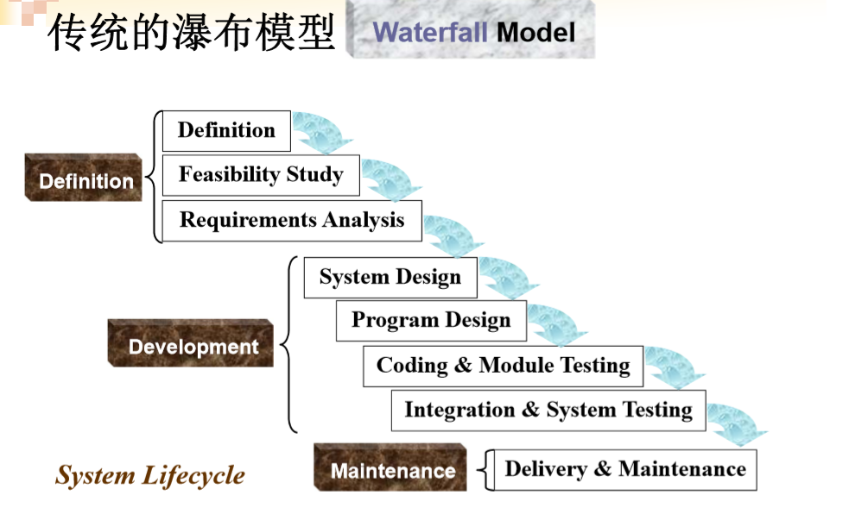

优点

Standardize the process of management and development

Document driven

缺点

It is difficult to fully determine the requirements of the initial system.

Document driven

Cycle length

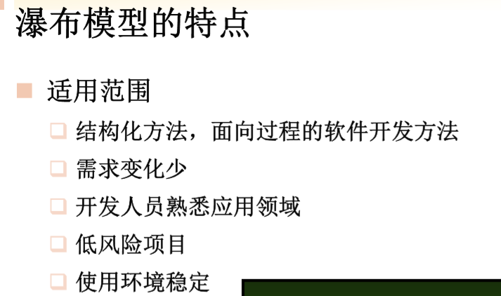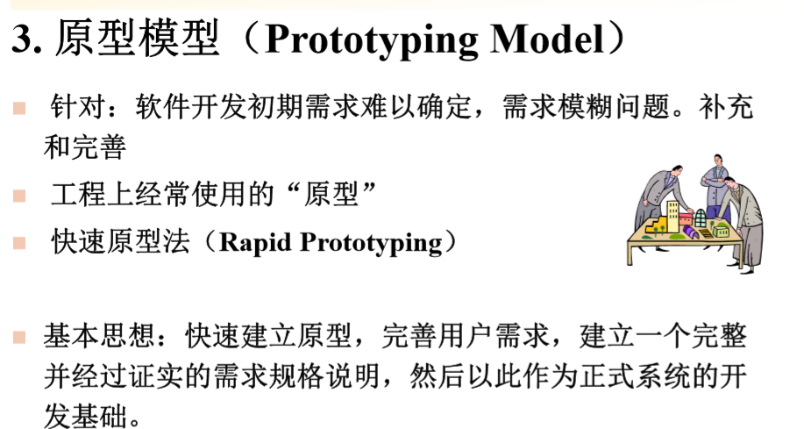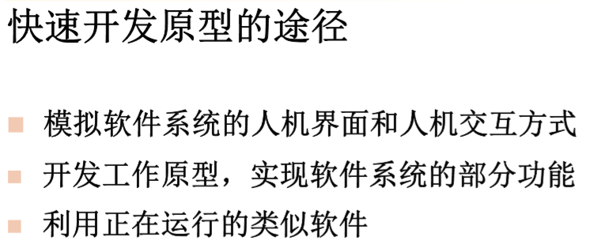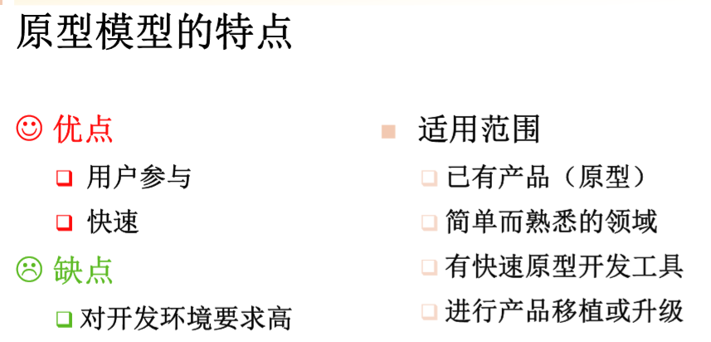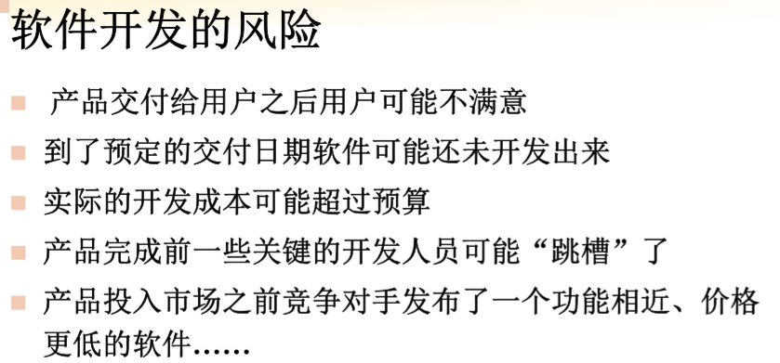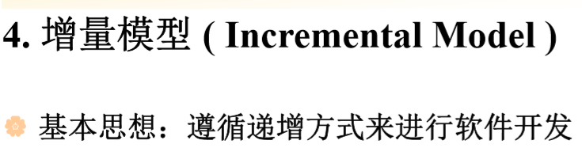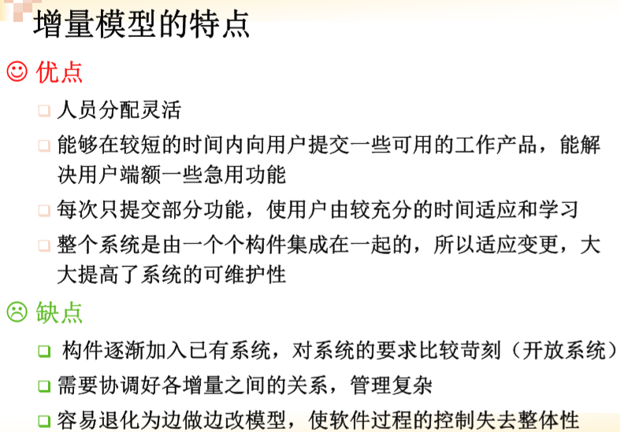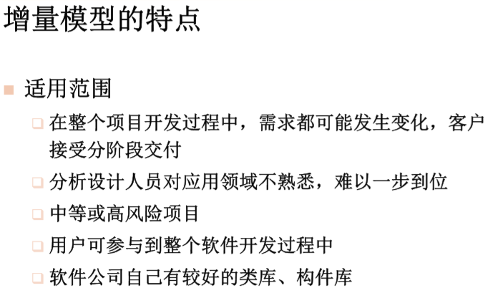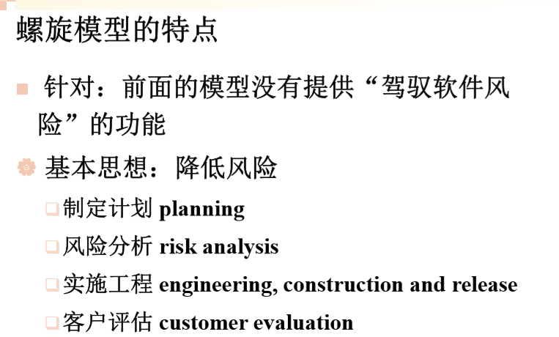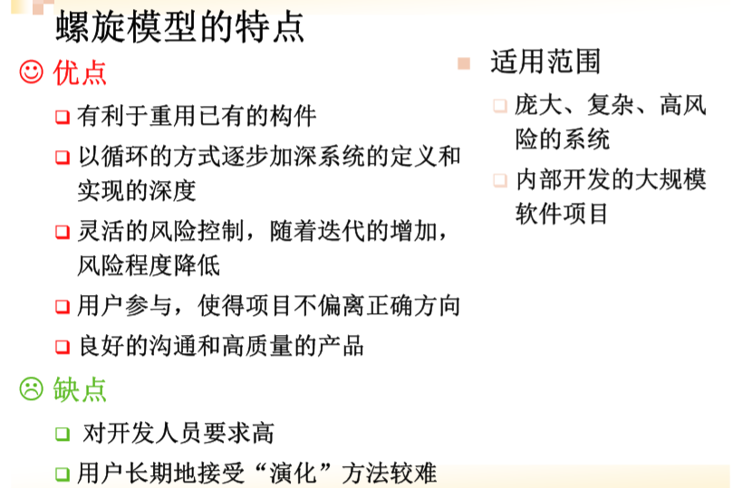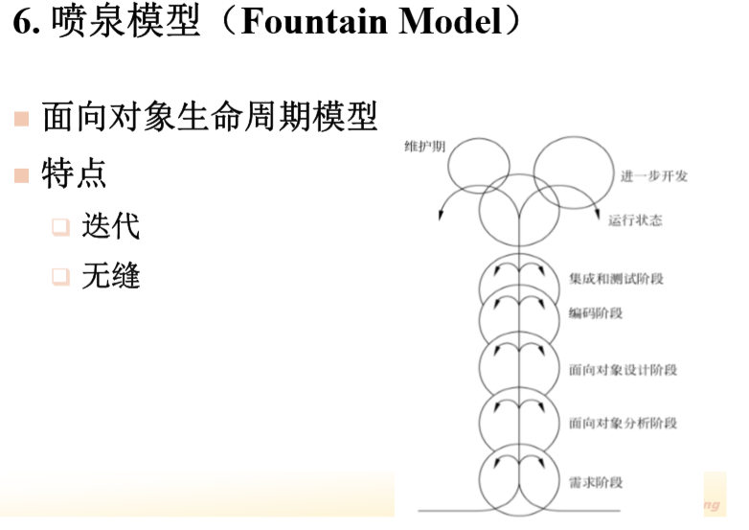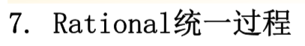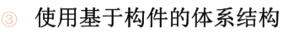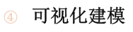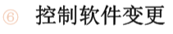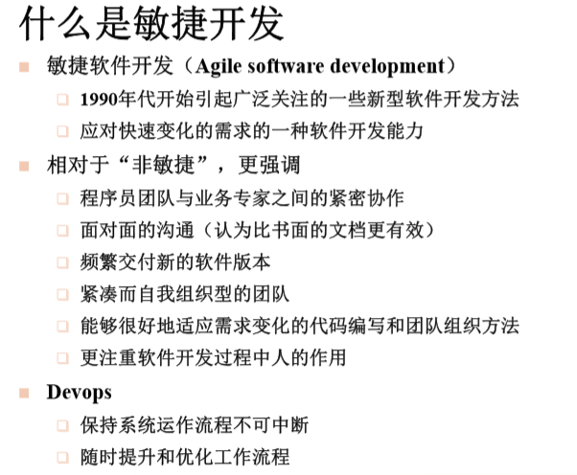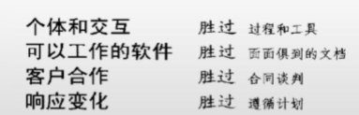

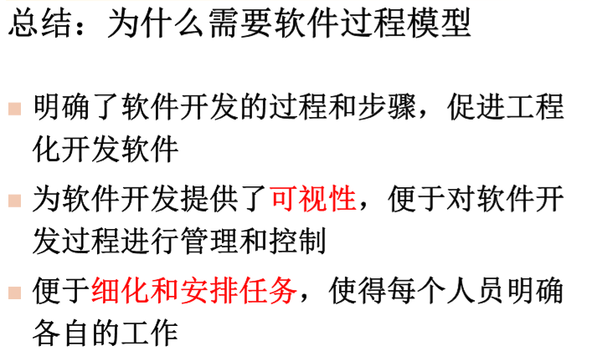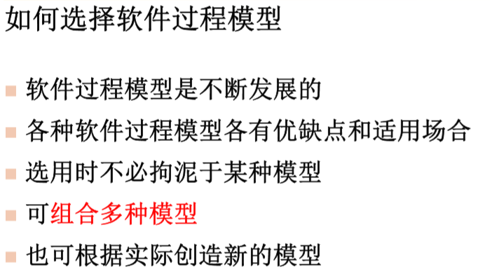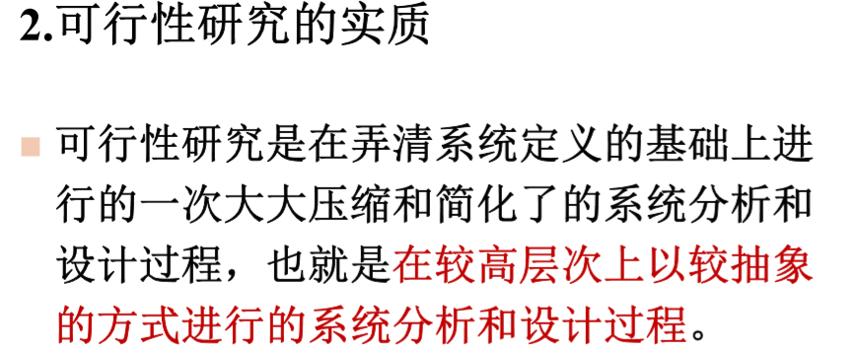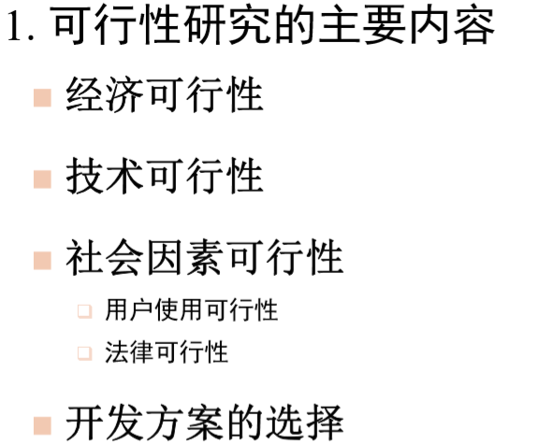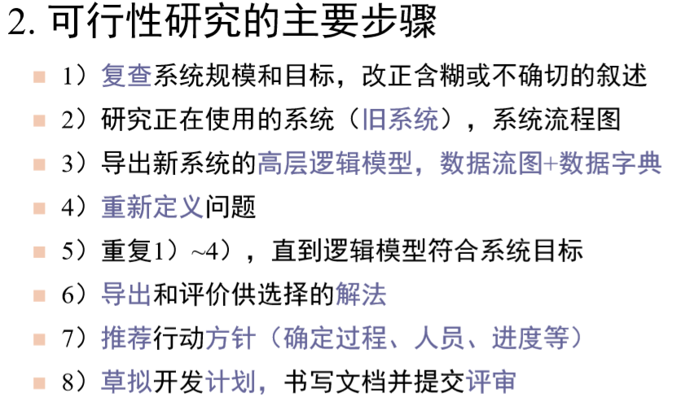

System Flow Chart (Business Flow Chart)

Traditional Tools for Describing System Physical Models

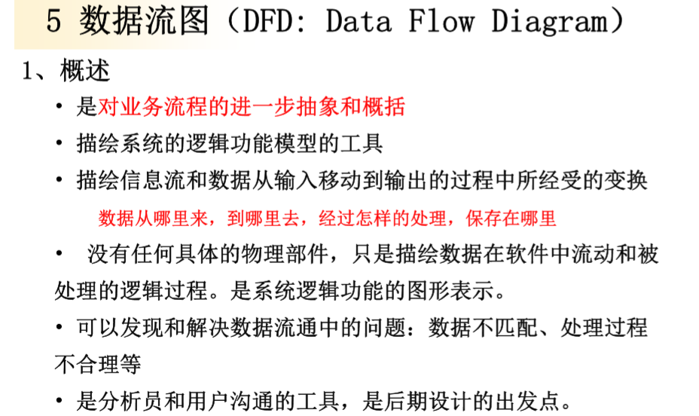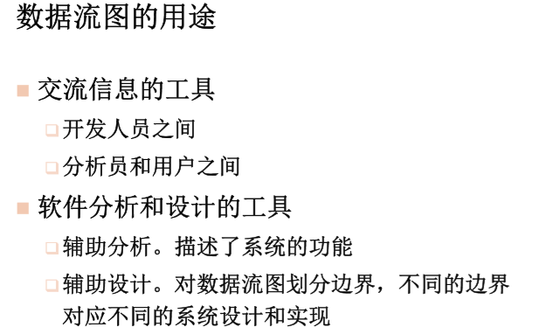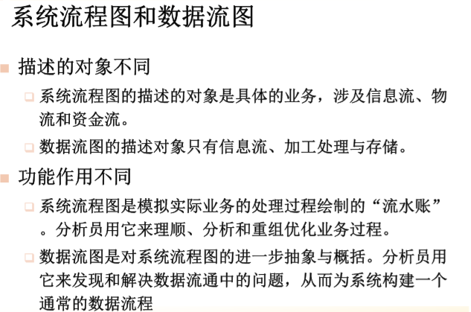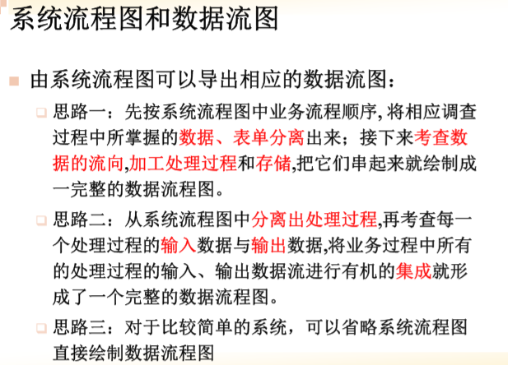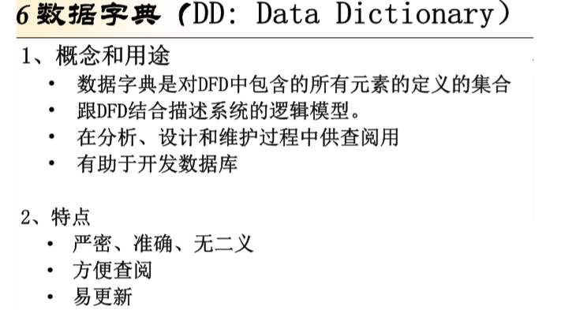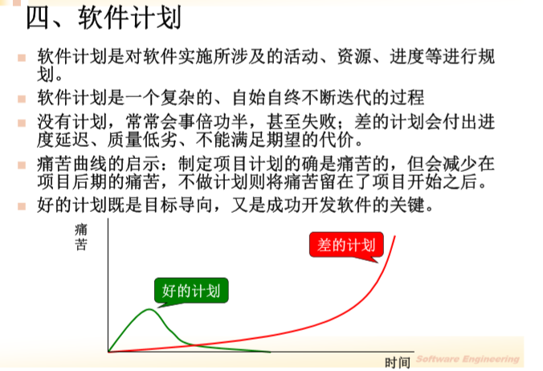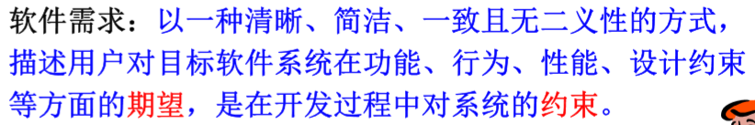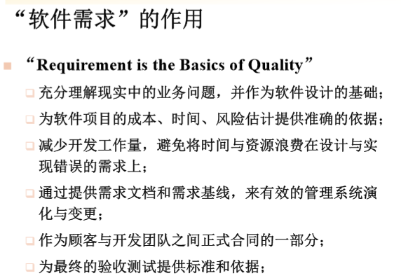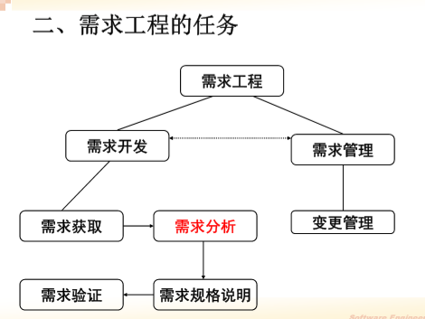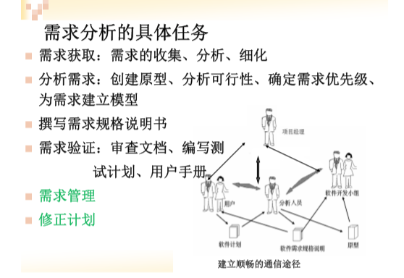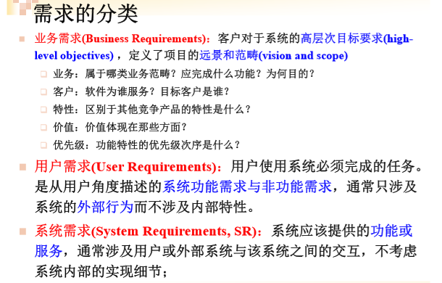

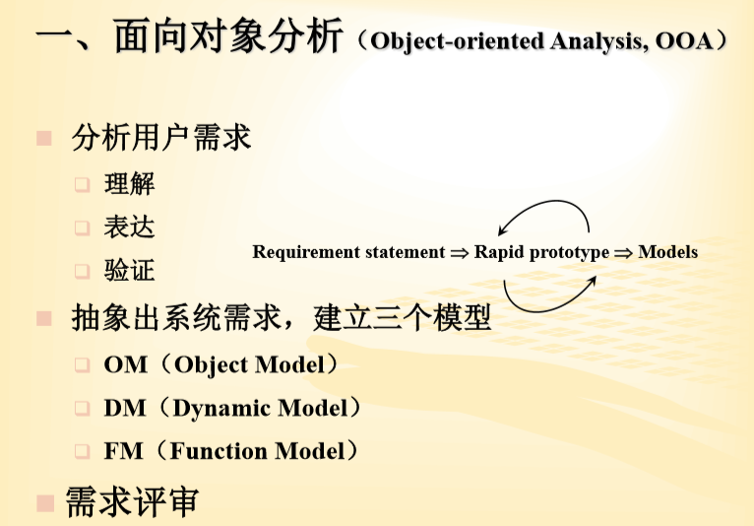

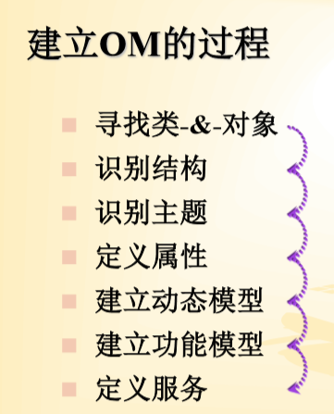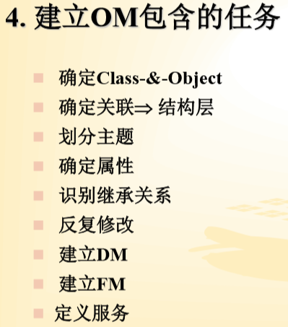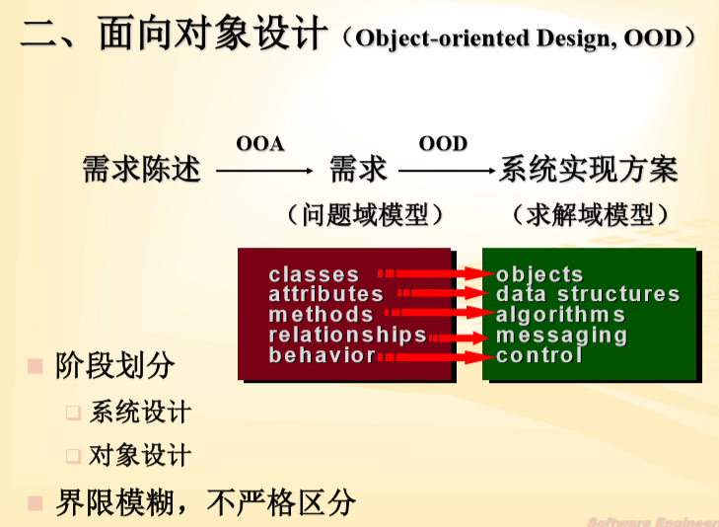

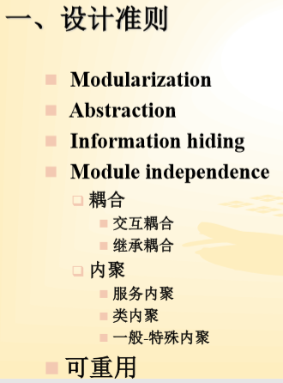

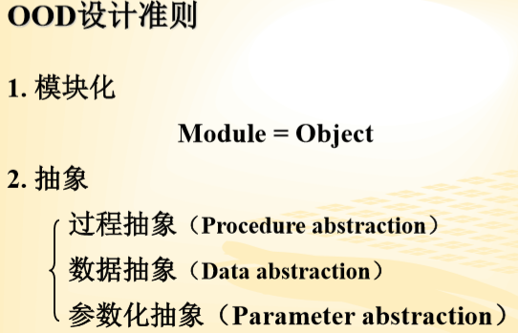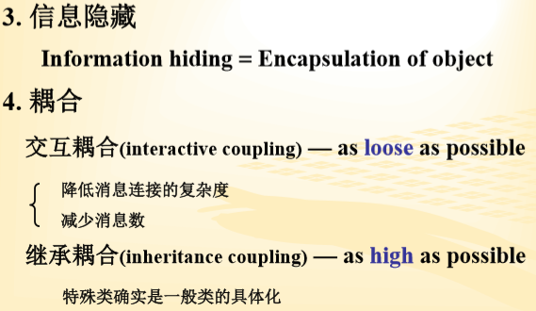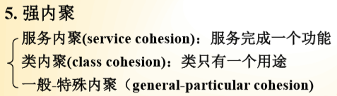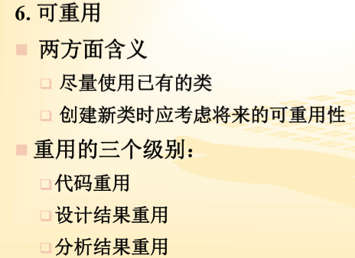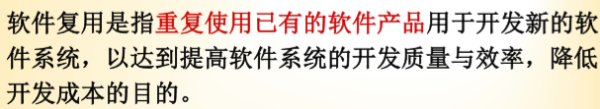

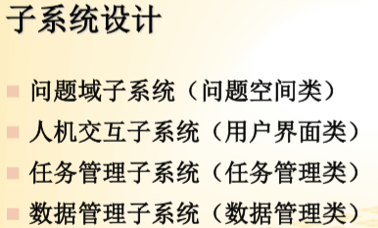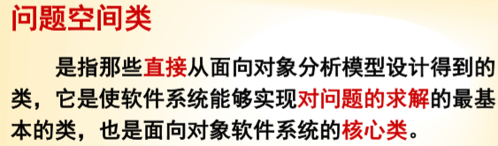

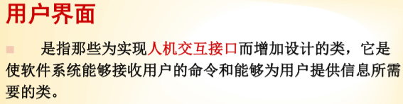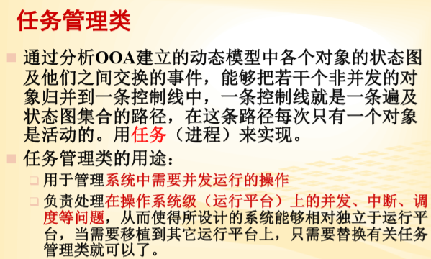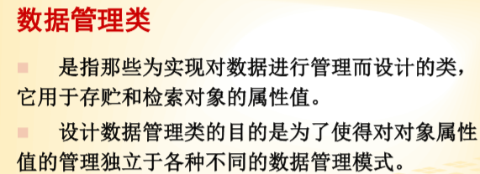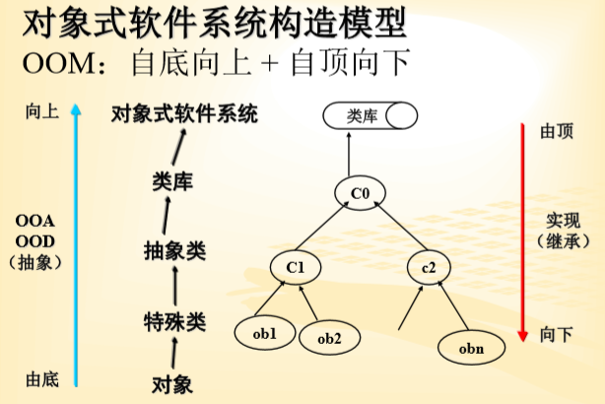

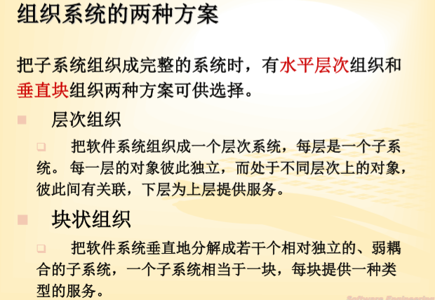

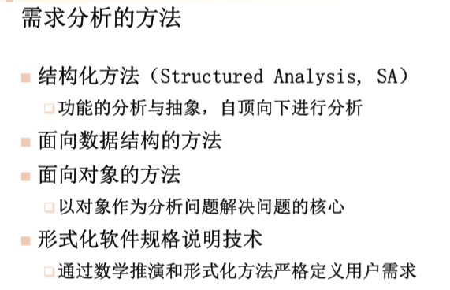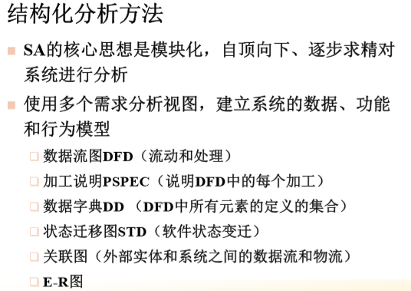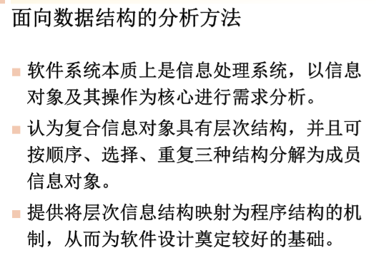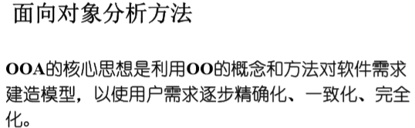

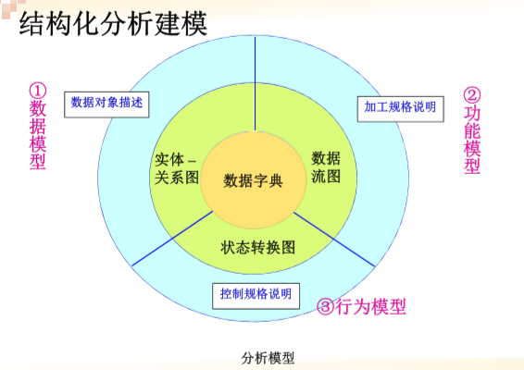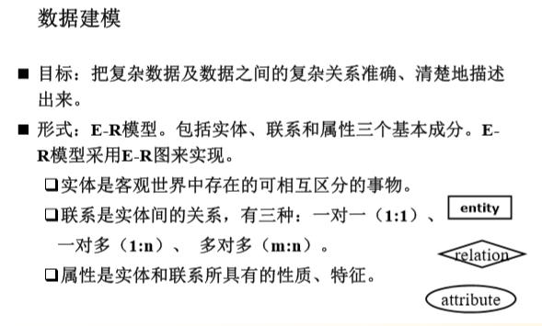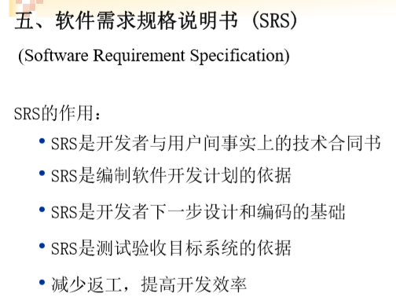

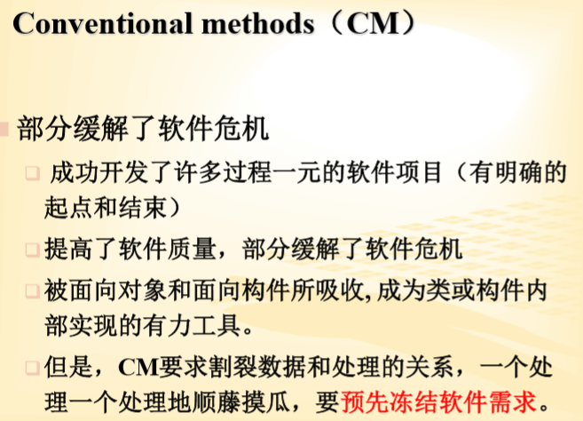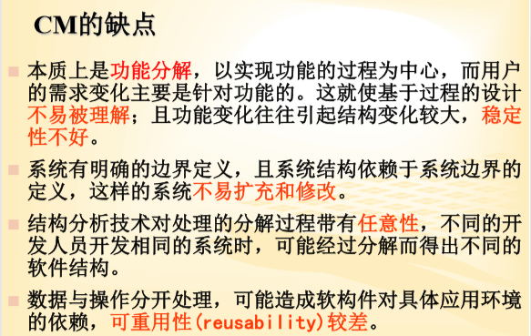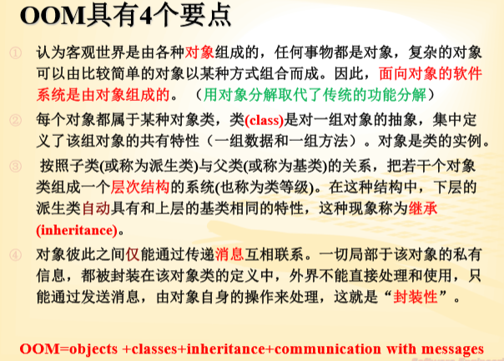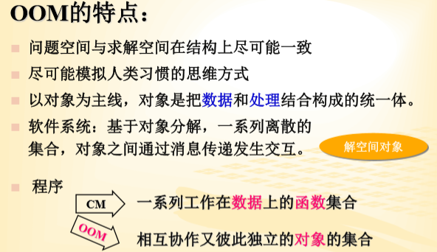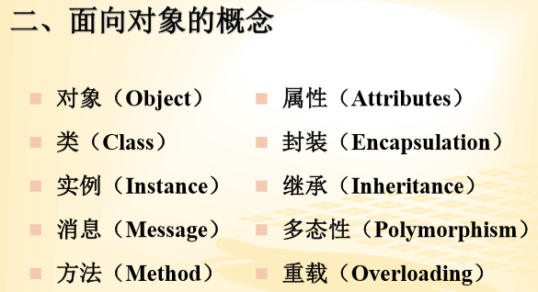对象是系统中用来描述客观事物的一个实体，它 是构成系统的一个基本单位。对象由一组属性和 施加于这些属性上的一组操作构成

每个对象均有自己的惟一标识，从而区别于其他对象。 ➢

对象之间通过消息进行通信。 ➢

对象总是处于一定的状态。 ➢

对象有若干种行为。 ➢

对象的行为分为三类：创建新对象、通过接口与其他对象 通信、改变自身状态。

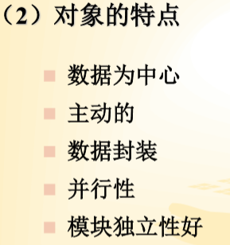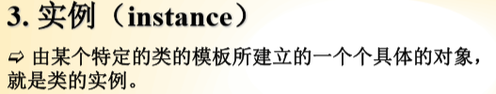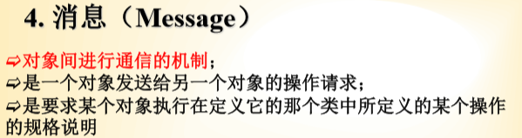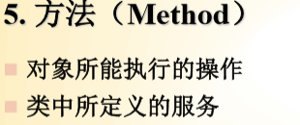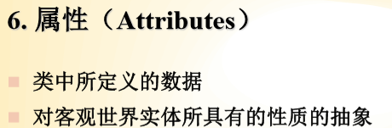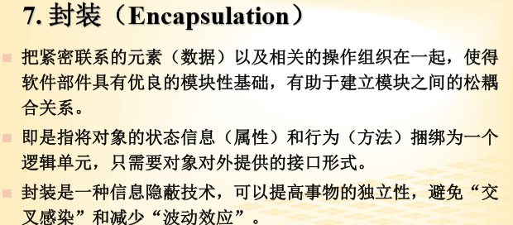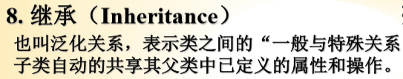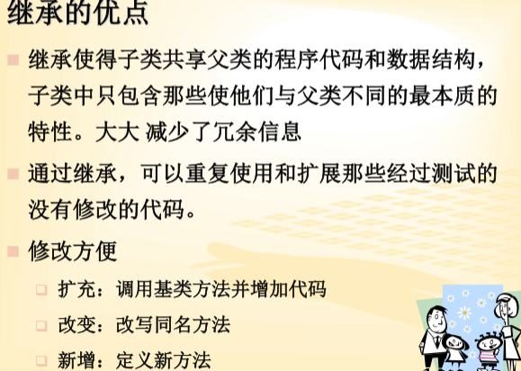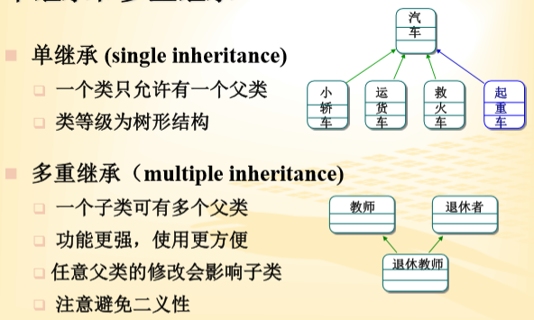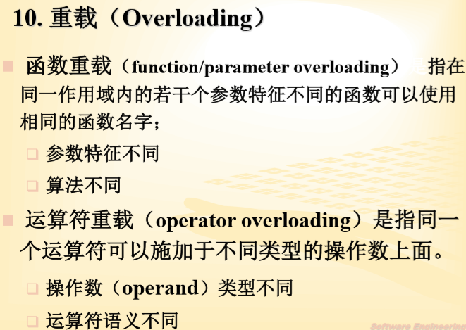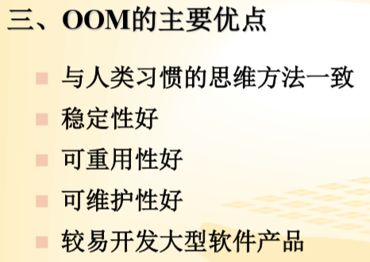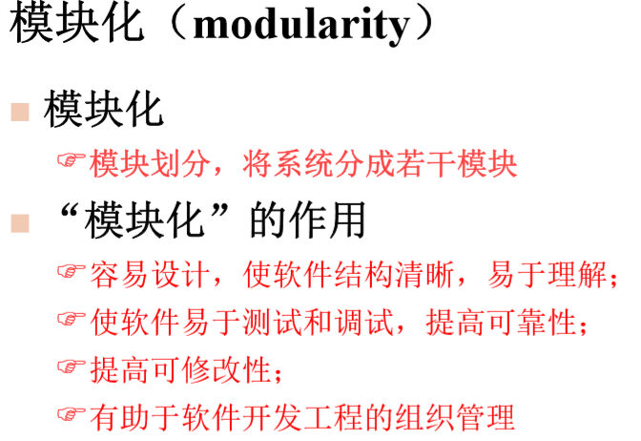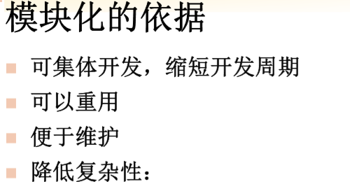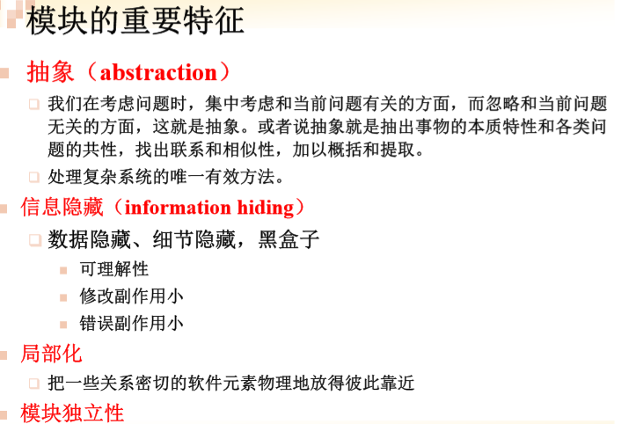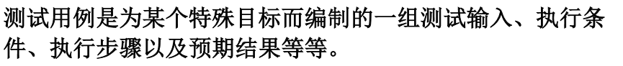

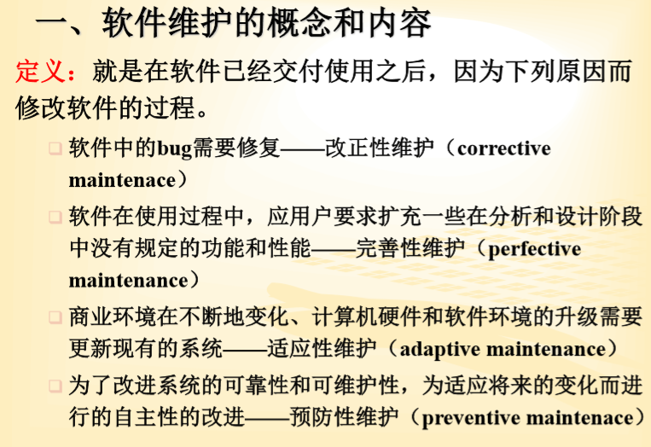

1. In object-oriented systems

(a) inheritance and polymorphism make reused code easy to understand

(b) small self-contained objects facilitate reuse, but other problems complicate it

(c) small self-contained objects guarantee a high degree of reuse

(d) code reuse is impossible

Correct answer is (b) 错

1. Which of the following are advantages of top-down integration testing of software?

It helps isolate faults to lower modules as they are added.

It helps debug lower-level modules faster.

It helps identify design faults earlier in the process.

(a) III only

(b) I, II, and III

(c) I and III only

(d) I and II only

Correct answer is (c) 对

3. Which of the following normally happens during the **implementation** phase of software development?

(a) Modules are coded and then the modular architecture is revised.

(b) Modules are coded but not tested.

(c) Modules and architecture are documented.

(d) Modules are coded and tested.

Correct answer is (d) 对

4. **Regression testing** for a software development project is testing to determine whether

(a) any modules inside a changed component still communicate correctly

(b) a component that was unchanged during changes to other components still performs correctly

(c) a module or product hasn't lost code

(d) a problem that instigated an attempted fix has indeed been fixed

Correct answer is (b) 对

5. Maintenance is normally required in

(a) incompletely specified software products

(b) imperfectly designed software products

(c) almost all software products

(d) badly implemented software products

Correct answer is (c) 对

6. When the only documentation available for a software code is the code itself, the process of reconstructing the design and specifications is called

(a) reengineering

(b) reverse engineering

(c) backward engineering

(d) forward engineering

Correct answer is (b) 错

7． Which of the following is (are) true in a module with informational cohesion?

Each action has its own entry point

Each action has independent code

All actions work on the same data

1. II and III only (b) I, II, and III (c) III only (d) I and II only

Correct answer is (b)错

8． A feature of the spiral model that distinguishes it from other life-cycle models is the

(a) presence of feedback between phases

(b) use of risk analysis prior to each phase

(c) appropriateness of use for both internal and contract software development

(d) applicability to both small and large-scale software products

Correct answer is (b) 对

9． In the waterfall model of software development, no phase is considered completed until which of the following have occurred?

The documentation for the phase has been written.

The developer's SQA group has verified the phase.

The client has made all payments associated with the phase.

1. I and III only (b) II and III only (c) I and II only (d) I, II, and III

Correct answer is (c) 对

10． Which of the following modeling techniques are used to capture information gathered during analysis?

Creating a modular architecture

Creating use cases and use case scenarios

Creating a preliminary class diagram

1. II only (b) I and III only (c) II and III only (d) I and II only

Correct answer is (c) 错

**11.**  Abnormal use case scenarios capture events such as which of the following?

Network errors /////Unexpected input data ////Software compilation errors

1. II only (b) I, II, and III (c) I and II only (d) I only

Correct answer is (c) 对

**12.**  Which of the following is true about object-oriented design?

(a) The most emphasis is given to the algorithms that relate the structure of the data to the actions operating on the data.

(b) Equal emphasis is given to the structure of the data and the actions operating on the data.

(c) More emphasis is given to the actions operating on the data than to the structure of the data.

(d) More emphasis is given to the structure of the data than to the actions operating on the data.

Correct answer is (b) 错